https://www.cambly.com/en/student/courses/60dcbc2f2ae6c8489ea4334b/60e1f0f8866fb9fa300cf72e

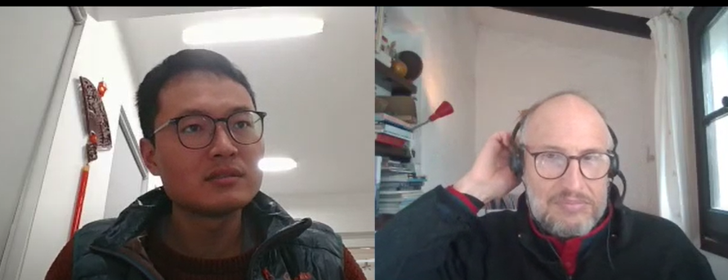

speed odometer

ask me a question

questions about .....

relationship

weak

schwa

decompose

Are you asking...

That's an interesting question ....

What do the results show anyone to know

**Be honest if you don’t know**

That’s interesting question, but we don’t have the answer for it. We can discuss the detail after the conference.

**Make sure the they know you are happy to answer the question**

That’s interesting question, I’m so glad and do my best to answer.

**Check in with the questioner**

Did that answer you question? Do you agree my answer? Is it clear or do I need to clarify more?

I’m hopefully that answered your question, but some if you would like some more information, just come and find me afterwards conference.

I am happy

That's an interesting question ....

潜力 potential / 位置position

**Could you explain the results of X more?**

**Could this study impact other areas of research?**

If I know, these results might impact …

If I don’t know. I’m not sure. I would need more information to answer that question. I can contact you after the presentation.

**What are the implications of these findings?**

There are several implications here. First …

That’s a great question. We can look back at this slide to answer that.

Find summary/conclusion, general method, which could be used in other field.

Operation research: make the optimal result from organizing the relationship among ,oney, worker, and resource/

clamp /klæmp/ , c**al**m /kɑːm/

**Asking off topic questions**

Q:I know you haven’t looked into this, but I was wondering if you thought about?

A: If I know, relative

If I don’t know, it is interesting question, we can dicuss after the conference.

**Being too critical**

Q: I don’t think that you did enough research on that. Why didn’t you think about xyz?

A: I think 5 seconds before answering.

I am sorry,

**Questioning your knowledge**

Q: Are you sure you know how to talk about this topic? It doesn’t seem like you have a lot of background information?

A: I’m sorry, it wasn’t clear/ you didnot understant. Is there any background information that you would like to know? I’d be happy to explain it to you well.

… depend on you audience (senior professor, peer)

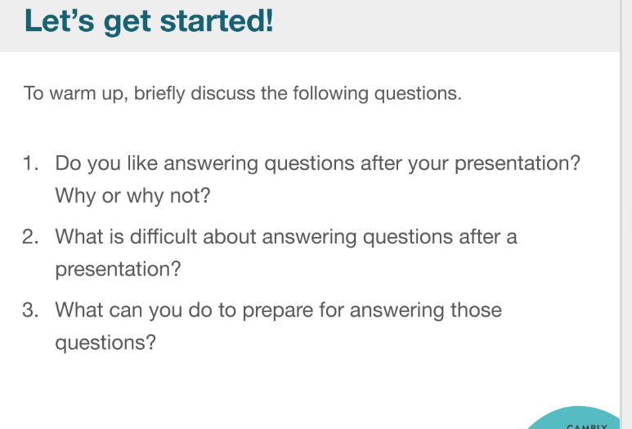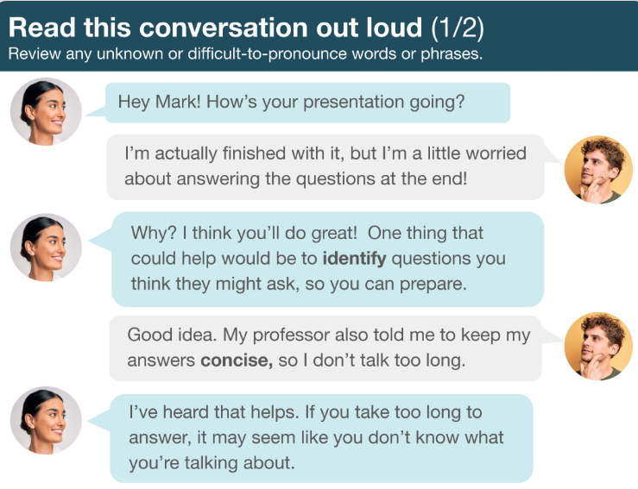

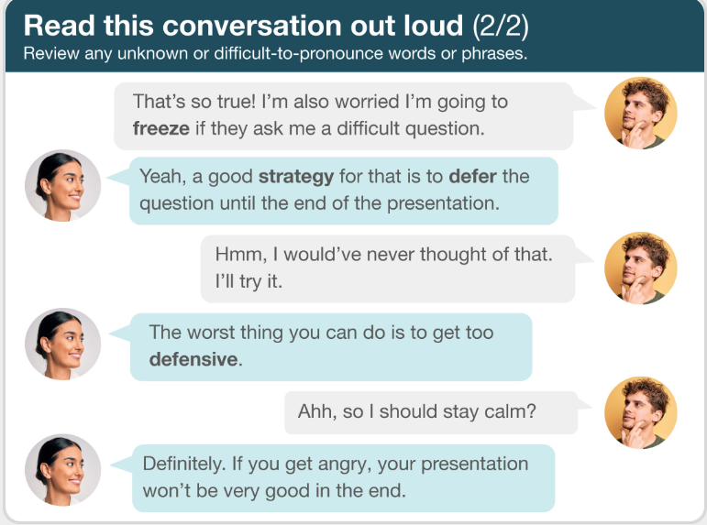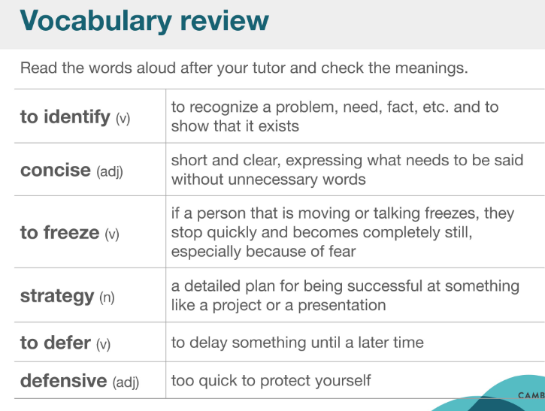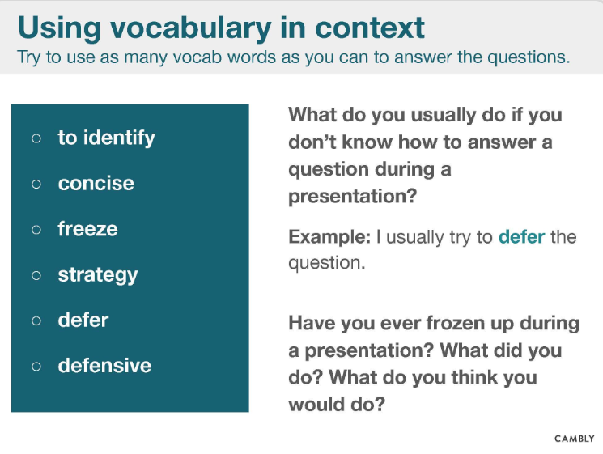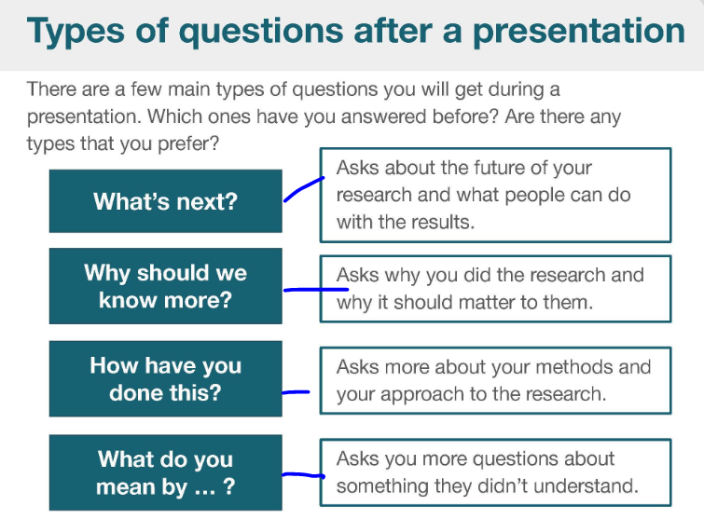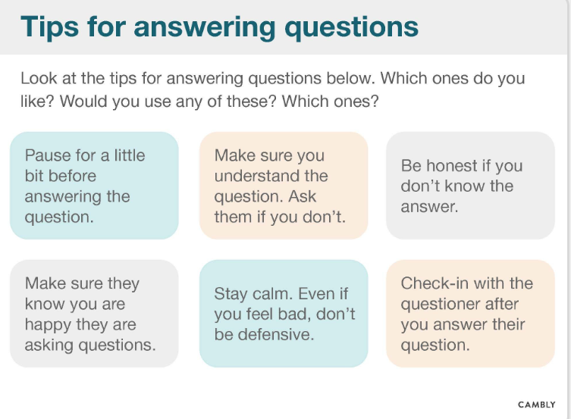

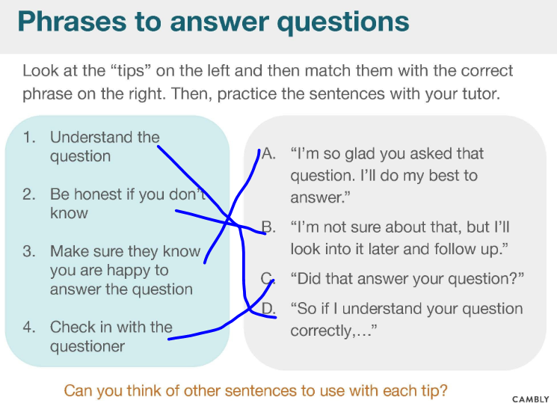

What do the results show anyone to know

**Be honest if you don’t know**

That’s interesting question, but we don’t have the answer for it. We can discuss the detail after the conference.

**Make sure the they know you are happy to answer the question**

That’s interesting question, I’m so glad and do my best to answer.

**Check in with the questioner**

Did that answer you question? Do you agree my answer? Is it clear or do I need to clarify more?

I’m hopefully that answered your question, but some if you would like some more information, just come and find me afterwards conference.



I am happy

That's an interesting question ....

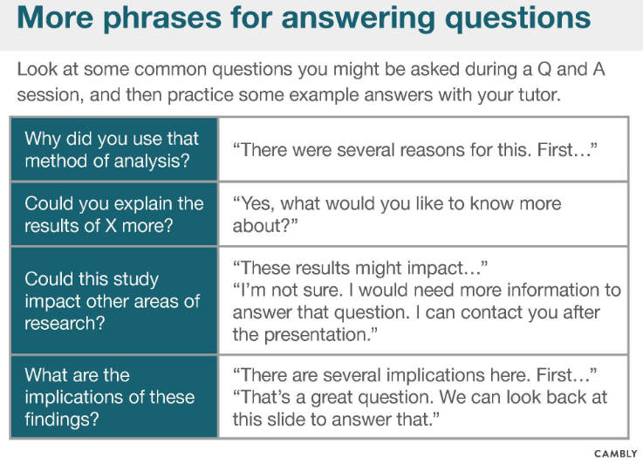

潜力 potential / 位置position

**Could you explain the results of X more?**

**Could this study impact other areas of research?**

If I know, these results might impact …

If I don’t know. I’m not sure. I would need more information to answer that question. I can contact you after the presentation.

**What are the implications of these findings?**

There are several implications here. First …

That’s a great question. We can look back at this slide to answer that.

Find summary/conclusion, general method, which could be used in other field.

Operation research: make the optimal result from organizing the relationship among ,oney, worker, and resource/

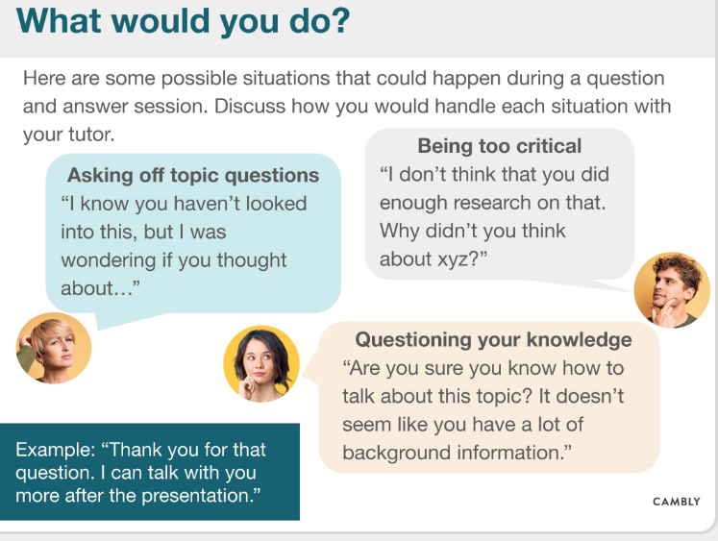

Clamp , calm

**Asking off topic questions**

Q:I know you haven’t looked into this, but I was wondering if you thought about?

A: If I know, relative

If I don’t know, it is interesting question, we can dicuss after the conference.

**Being too critical**

Q: I don’t think that you did enough research on that. Why didn’t you think about xyz?

A: I think 5 seconds before answering.

I am sorry,

**Questioning your knowledge**

Q: Are you sure you know how to talk about this topic? It doesn’t seem like you have a lot of background information?

A: I’m sorry, it wasn’t clear/ you didnot understant. Is there any background information that you would like to know? I’d be happy to explain it to you well.

… depend on you audience (senior professor, peer)

